Evaluation Guide:
• Describe the concept of you work (what is it about?)
The 1960 poster Me, Myself and I

• Review the ideas development and production process; what inspired your ideas
I looked up the PowerPoint looking at the 1960 poster. I come with the idea to present my own 1960 poster with my interests and colours represent my emotions. For example, I have chosen yellow as the main feature, it represent joy. The colour pink, the borders represent love.

• Explain the design; analyse the use of texture, shape, pattern, colour; filters,
The colour I used is bright because it’s a type for 1960. The pattern use is transform to make the text wavy and bigger.

• Explain the tools, effects and methods used in Photoshop and explain the effects achieved
The tool I use is colour adjustment to fill the solid colour on my poster. The apply effects to separate with red, green and blue which give a comical outcome on the image. The first tool is paintbrush to draw the lines for the text. This was used at the beginning before adding the text and image.

• List the problems experienced and solutions applied
The problem is to apply comical effects to my photograph. The problem is I haven’t set the colour correctly.

• Review feedback received from other students and tutors. Examine their comments and provide list of actions taken to improve the quality of the project
What you like about it | Even better if
The poster looks fantastic and great use of colours, and the picture itself blend well with colours in the background. | Writing should be bit big and fill in the spaces.
Your poster looks really good, good use of different colours. The words relate to the image you have chosen | Nothing needs to be improved. Look good

• Compare your poster with similar design, and comment on qualities
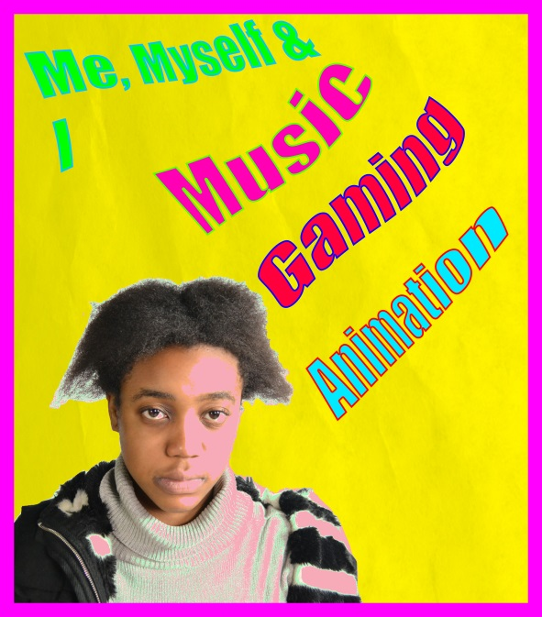
Compared to my poster, I looked and follow the tutorial. However, I need to add more something that relates to my poster like text or symbols. Also, I need a change bit of tonal colour linked to 1960.

