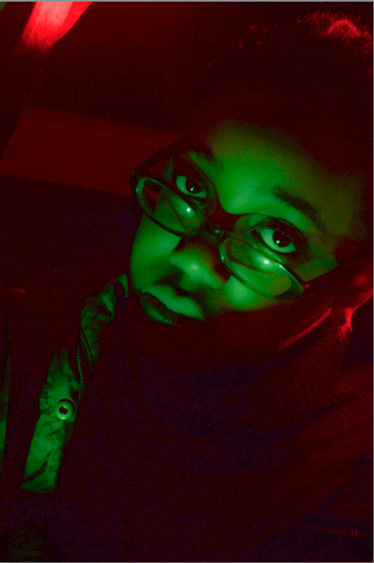
Evaluation
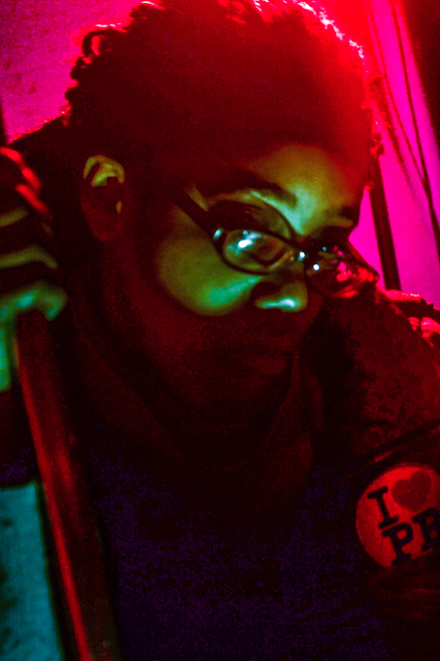
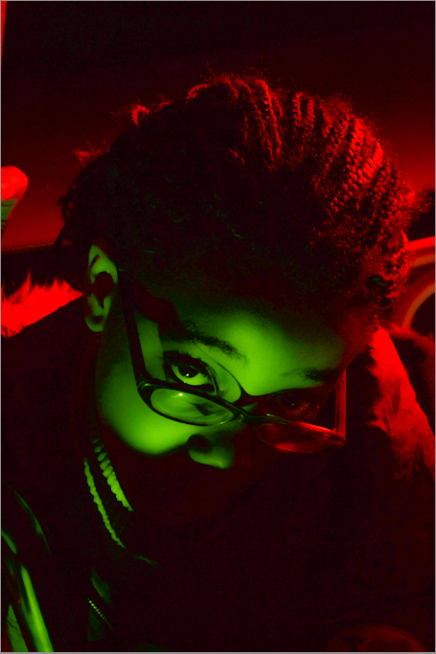

These are the photos I have taken for horror effects in Studio.

The new techniques I found easy are;
- Using the Adobe Lightroom to make the image sharpen, boast up the lighting, colours and clarifier.
- Using the Gels to take horror shots. Creating colour effects when taking the picture. Taking horror shot was fun creating the atmosphere and doing different positions.
- Taking different shots of depths of fields outside of using available light by changing the aperture. For instance F2.8 gives a little depth of field and F22 gives lots of depth of field. Fox example, fashion or sports photographers don’t use lots of depth of field, only landscape photographers use a lot.
- Posting up the images and writing caption on my blog site. This was my first time creating my own website on Wordpress.
- Taking photograph with the Nikon camera.
- Set in Manuel Mode that I am able to control the setting in the camera, more creative of the image and more professional.
- Setting the iOS to give good quality and less light.

The techniques I found hard are:
- Changing the menu on the camera
- Setting the continuous lighting
- How to use the studio flash to take a picture
- Choosing the focus on the image when taking a picture, when done automatically or manually causing blurriness.
- Export the picture as JPEG from Lightroom, but it was easy at the end.
- Using the shutter speed in manual. For example, the picture becomes dark when it was set on manual.

Things I done successful about final image:
- The picture was well focus and taken the close angle
- It has a lot of colours, contrast and stands out
- The lighting is good when taking a picture
- The picture was taken fine

Things I might do better next time are:
- Needs to be more focused on the centre of the photo
- It needs to be a bit more sharper
- The quality needs to be a bit clear
- Might taken everything than only the phone

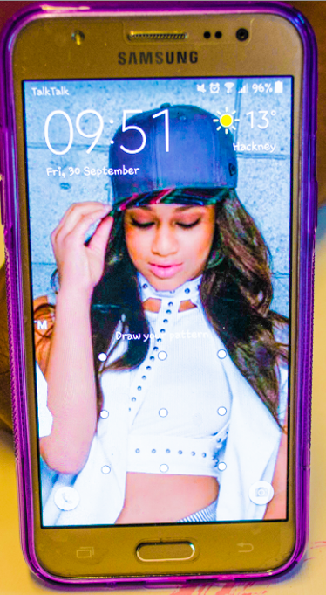

This picture was developed in Lightroom. I boasted the colours, sharpen and use clarity to clear the image. I found it very easy to change the exposure using some of the exposure sliders and I used the vibrance tool to boost the colour.

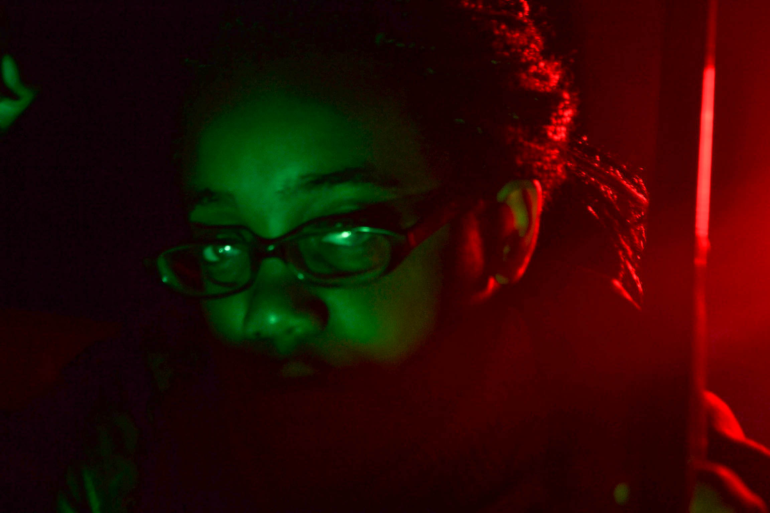
On shutter speed, the reason why the picture doesn’t work because I set it to the wrong speed, it was too fast, that’s why it’s dark. To make it brighter, I will have to use the slower speed. Another way to improve this photo would be to focus on the eyes and not the hair. I think this happen because it hard to focus on the dark.

